**SNOW CAMPING at Loon Lake**

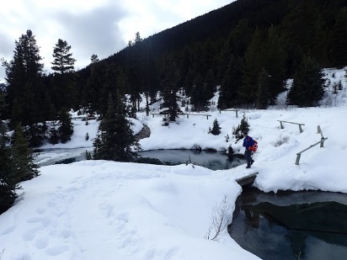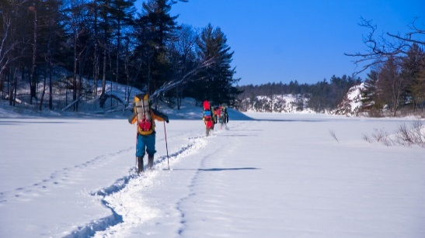

**Saturday, February 2nd – Sunday, February 3rd, 2019**

# Overview

This is a weekend of Snow Camping with the Luxury of a cabin. We will be staying the Loon Lake Chalet, more details can be found at:

https://www.recreation.gov/camping/campgrounds/232348

This is a great outing for starting off the New Year. It will be an opportunity to enjoy building of snow structures, as well as snow shoeing and other winter type activities. Adults are welcome to participate. We can reserve up to 20 spots

**Overview:** The chalet is nestled in the forest on the western edge of Loon Lake at an elevation of 6,348 feet. The lake spans 76,200 acres. Sub-alpine red fir and lodgepole forests, granite bowls and a spectacular view of the Crystal Range of the Sierra Nevada Mountains characterize the area. In winter, the chalet is the focal point of the Loon Lake Winter Recreation Area, which offers many miles of non-groomed backcountry skiing trails We will come home Sunday afternoon.

**Site:** Take Highway 50 east of Placerville for 21 miles to Icehouse Road turnoff. Turn left and go 25 miles north to a fork in the road. Take the right fork 6 miles. Pass the Loon Lake Campground turn-off, then go 3/4 of a mile to the chalet

**Meals:** Your meal expense will depend on the menu adopted by your patrol. The person responsible for meal planning will coordinate purchase of food and advice per person cost. ***Saturday Breakfast:*** Eat prior to the departure or bring your own “bag breakfast’; if you plan to buy at Safeway, adjust your arrival time, so you are ready to depart *promptly* at 6:30 AM.

|  |  |  |  |
| --- | --- | --- | --- |
|  | **Cooking/Meals** | **Special/Important Gear For This Outing** | |
|  | Cabin has amenities for cooking   * Scouts can arrange to bring patrol boxes and cook outside if desired * Should plan for:   + Saturday Lunch   + Saturday Dinner   + Sunday Breakfast | * Sleeping bag and pad and basic personal camping gear for 1 night camping * Personal Mess kit and eating utensils * Personal Gear and towel | |
|  | **Advancement Opportunities** |  | **Special Activities** |
| * Hiking * Planning/Cooking of Meals | | * Campfire (Be prepared with worthy jokes, stories, skits) * Possible Geezer Cobbler | |
| **Departure** | | **Return** | |
| Meet Saturday, at 6:00 AM Saturday, Safeway parking lot. Leave by 6:30 AM SHARP. | | Break camp by noon, Sunday. Lunch stop will be driver’s choice Sunday ~3:00~4:00pm, scouts dropped-off at their homes | |
| **Sign-up & Cost** | | **Outing Coordinator** | |
| * $27 per Scout * $27 per Adult * Cost includes allocated Budget for 1-Lunch / 1-Dinner / 1-Breakfast, but does NOT include Food driving to & from outing * **$’s will be due by January 26tj** | | Frank Friedrich: (W) (408)-282-3813  Frank.Friedrich@Colliers.com  **MAIL MATERIAL TO:**  22551 San Vicente Avenue  San Jose, CA 95120 | |

Wear “CLASS A” uniform “TO” & “FROM” this outing

|  |  |  |  |  |  |
| --- | --- | --- | --- | --- | --- |
| **Snow Camping at Loon Lake** | | | | | |
| Total Number of Participants: | | Participant Names: | | | |
| Parent Signature: | | | | | |
| Advancement MB Requests/Interest: | | | | | |
| Can you drive scouts  **TO OUTING**? (circle one)  YES / NO | Passenger Capacity **TO OUTING** (total w/ driver & gear) | | NOTES | Can you drive scouts  **HOME FROM OUTING**? (circle one)  YES / NO | Passenger Capacity **FROM OUTING** (total w/ driver & gear) |
| Vehicle Type **TO OUTING**:  (circle one if driving  Sedan / Van / Wagon  Truck / SUV | Roof Rack **TO OUTING**?  (circle one if Driving)  Yes / No | | Vehicle Type **FROM OUTING**:  (circle one if driving  Sedan / Van / Wagon  Truck / SUV | Roof Rack? **FROM OUTING**  (circle one if driving)  Yes / No |
| Email(s) that can be used to correspond with you regarding this outing: | | | | | |
| Cell Phone(s) that can be used to correspond with you regarding this outing: | | | | | |
| Special Considerations (Advancement requests, medications needing to be dispensed on outing, allergies, etc.) | | | | | |

Wear “CLASS A” uniform “TO” & “FROM” this outing

Contact:

Frank Friedrich 408-282-3813

[Frank.Friedrich@Colliers.com](mailto:Frank.Friedrich@Colliers.com)

**Personal Gear List for TTFC:**

**Appropriate dress to/from outing**. **Wear your Class A uniform and troop Buzzard shirt**.

**Important Gear For This Outing**

* Sleeping bag and pad
* Personal eating utensils/plate/cup (mess kit)
* Wear layers. Warm clothing as the nights can get cold

**General Gear List**

|  |  |
| --- | --- |
| **Camping/Hiking Gear**   * Day pack (for day hikes) * Sleeping bag * Ground sleeping pad * Water bottles/canteen * Mess Kit (plate, cup, utensils)     **Emergency Kit/First Aid Kit**  *this is ideally kept in fanny pack for hikes/out of camp use*   * Band aids * Sunscreen * Chapstick * Anti-bacterial ointment (Neosporin) * Compass * Pocket knife (w/ totem chit card) * Mole skin * Emergency whistle * Flashlight / headlamp * Matches in waterproof container * Emergency blanket (space blanket)       **Optional**  *depends on type of outing/personal preference*   * Sunglasses * Camp chair * Camera * Binoculars * 10’ to 15' light-weight rope (hang clothes, etc.) * Cards * Work Gloves | **Clothing**   * Underwear * Socks * Buzzard T-shirts * Other weather-appropriate shirts * Pants / shorts (consider weather) * Jacket/sweatshirt (consider weather) * Warm gloves (if cold) * Rain poncho/rain clothing * Study shoes/boots * Cap/hat for sun protection * Warm hat/beanie (for cool weather sleeping)     **Toiletries**   * Toothbrush * Toothpaste * Soap * Hand towel * Camp mirror * Comb/brush     **Scout Book/Spending Money**   * Money for fast food/snack purchase * Scout handbook * Pen/Pencil * Notebook/notepad     **Unauthorized Items:**   * Firearms/ammunition, archery equipment, fireworks * Illicit drugs, Alcohol * Electronics (radios, PSP, etc.) * Cell phones (Turn in your cell phone to adult leaders upon arrival) * Knives with blades longer than 3” or Fixed-blade or weapons of any kind * Expensive items * Animals |

***Note: Use your own judgment regarding appropriate gear for the specific outing planned. If you do not have a tent, you can find someone to share with or there are a few available from the troop.***